DAF N.V. manufactures world-famous trucks with BOGE's latest oil-free compressed air technology
June 12th, 2017
Two BOGE High Speed ​​Turbo compressors now provide the plant of DAF with compressed air
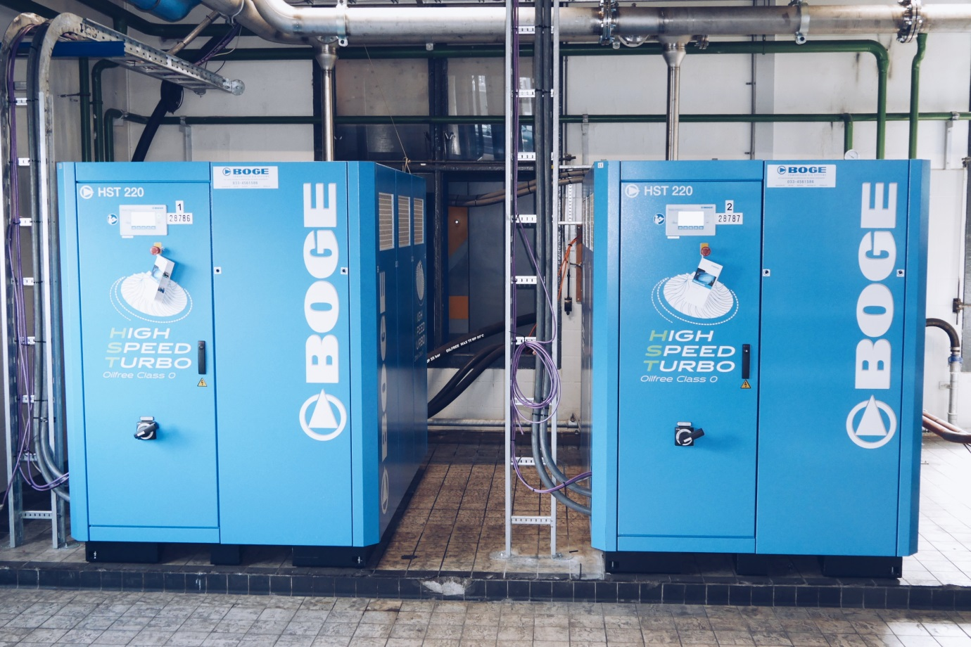
EINDHOVEN - Air compressor manufacturer BOGE has installed two High Speed ​​Turbo compressors in the manufacturing plant of DAF Trucks NV in Eindhoven. The production at DAF Trucks is now supported by these two innovative oil-free compressors.
New benchmark for oil-free compressed air
The high tech industry is increasingly demanding compressed air of a higher quality. In order to meet this requirement, BOGE has developed a number of completely oil-free installations, including the HST series. These compressors do not contain any oil at all and are therefore of the Class 0 quality standard. With the high speed turbo technology, BOGE has set a new benchmark for oil-free compressed air. And by radically reducing the number of components (the compressors have shrunk to half the size and a third of the weight) while simultaneously using a new design principle that guarantees low-wear operation, a significant improvement in efficiency has been achieved.
Own master of compressed air
And that's exactly what DAF was looking for, says Ton van de Weetering, Commodity Manager at DAF Trucks NV. "We are always looking for new opportunities to keep innovating and making the production more efficient. The BOGE High Speed ​​Turbo compressors help us realizing this. DAF symbolizes innovation and renewal, just like BOGE. With this new installation we can also regulate our compressed air ourselves.
24/7 remote monitoring
In addition, with the option of 'Remote Monitoring' DAF can see all data of the compressed air consumption itself. That does not mean that they are thrown on their own resources: 24 hours a day, seven days a week, BOGE engineers from the production plant in Bielefeld, Germany monitor the system. Overriding a limiting value or unusual device operation is thereby quickly detected and can be rectified soon.
Always looking for improvement
The Remote Monitoring option is part of the BOGE enhancement program. This means that BOGE actively suggests improvement possibilities for components of the specific compressor installation.
Mutual trust
Ronald Engberts, Country Manager BOGE The Netherlands: "BOGE is a typical family company and we feel strongly about innovation and personal service. We are very proud of the confidence that DAF has in us and our products and specialists. And that trust is apparent from fact that we will provide the plant with another four additional compressors in the near future. "
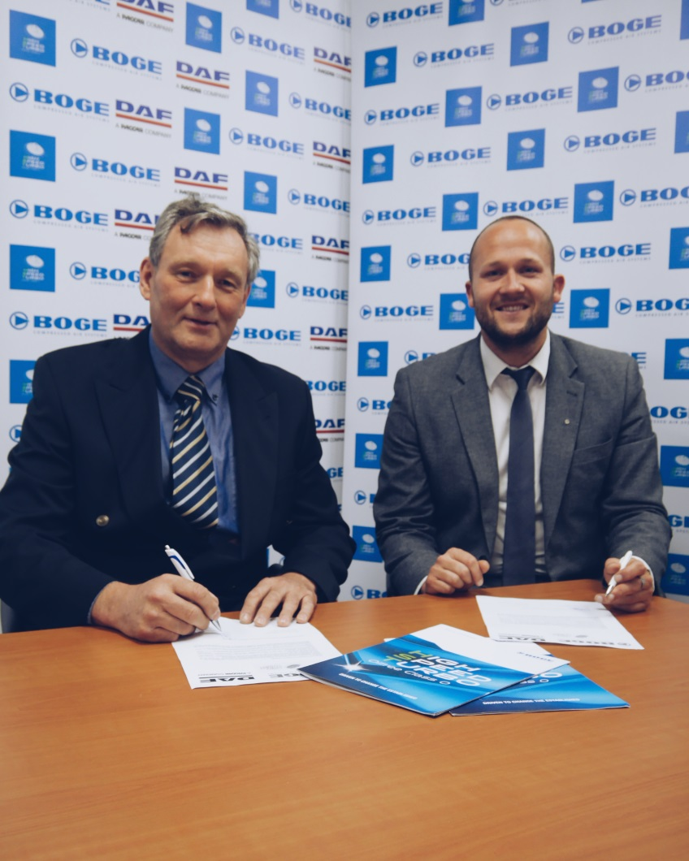
For every need a customized truck
DAF is undisputed market leader in the Dutch, English, Polish and Czech truck market and one of Europe's largest truck manufacturers. The company develops and manufactures light, medium and heavy duty commercial vehicles. For every transport need, DAF offers a tailor-made truck. Innovative, reliable, durable, efficient and comfortable for the driver, that's what DAF stands for.
ABOUT BOGE
With over 100 years of experience, BOGE KOMPRESSOREN B.V. is one of the oldest manufacturers of compressors and compressed air systems. The company is globally known as one of the market leaders. Whether it's High Speed ​​Turbo compressors, screw compressors, piston compressors, scroll compressors, entire plants or loose machines - BOGE knows meets the highest quality requirements. The company supplies its products and systems in more than 120 countries around the world.
Photo captions (freely usable):
1. Installation of the two High Speed ​​Turbo compressors in the DAF manufacturing plant in Eindhoven.
2. Ronald Engberts (Country Manager BOGE Netherlands, right) and Johan van der Linden (Maintenance Manager DAF, left) sign the agreement concerning the compressed air installation.
3. Logo of BOGE.
4. Product Photo of the High Speed ​​Turbo Compressor (HST).
BOGE contact
Kim van Weering • Marketing & Communication BOGE COMPRESSORS B.V.
Spaceshuttle 8B • 3824 ML Amersfoort
Tel: +31 33 456 1586
Mobile: +31 6 513 42 105
E-Mail: k.vanweering@boge.com • Internet: www.boge.com/en

